**Lab Session 9**



**Advanced Procedures**



**Objectives**

* Implementing procedures using stack frame
* Using stack parameters in procedures
* Passing value type and reference type parameters

**Stack Applications**

There are several important uses of runtime stacks in programs:

* A stack makes a convenient temporary save area for registers when they are used for more than one purpose. After they are modified, they *can* be restored to their original values.
* When the CALL instruction executes, the CPU saves the current subroutine’s return address on the stack.
* When calling a subroutine, you pass input values called arguments by pushing them on the stack.
* The stack provides temporary storage for local variables inside subroutines.

**Stack Parameters**

* **Passing by value**

When an argument is passed by value, a copy of the value is pushed on the stack..

**EXAMPLE:**

.data

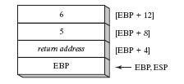 var1 DWORD 5

var2 DWORD 6

.code

push var2

push var1

call AddTwo

exit

AddTwo PROC

push ebp

mov ebp, esp

mov eax, [ebp + 12]

add eax, [ebp + 8]

pop ebp

ret

AddTwo ENDP

* **Explicit stack parameters**

When stack parameters are referenced with expressions such as [ebp+8], we call them explicit stack parameters.

**EXAMPLE:**

.data

var1 DWORD 5

var2 DWORD 6

y_param EQU [ebp + 12]

x_param EQU [ebp+ 8]

.code

push var2

push var1

callAddTwo

exit

AddTwo PROC

push ebp

mov ebp, esp

mov eax, y_param

add eax, x_param

pop ebp

ret

AddTwo ENDP

* **Passing by reference**

An argument passed by reference consists of the offset of an object to be passed.

**EXAMPLE:**

.data

count = 10

arr WORD count DUP (?)

.code

push OFFSET arr

push count

call ArrayFill

exit

ArrayFill PROC

push ebp

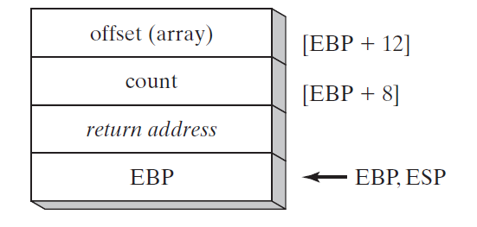 mov ebp, esp

pushad

mov esi, [ebp + 12]

mov ecx, [ebp + 8]

cmp ecx, 0

je L2

L1:

mov eax, 100h

call RandomRange

mov [esi], ax

add esi, TYPE WORD

loop L1

L2:

popad

pop ebp

ret 8

ArrayFill ENDP

**Local Variables**

In MASM Assembly Language, local variables are created at runtime stack, below the base pointer (EBP).

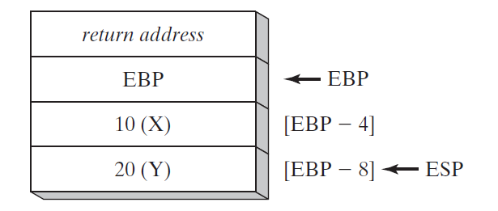**EXAMPLE:**

.code

call MySub

exit

MySub PROC

push ebp

mov ebp, esp

sub esp, 8

mov DWORD PTR [ebp - 4], 10 ; first parameter

mov DWORD PTR [ebp - 8], 20 ; second parameter

mov esp, ebp

pop ebp

ret

MySub ENDP

**LEA Instruction**

LEA instruction returns the effective address of an indirect operand. Offsets of indirect operands are calculated at runtime.

**EXAMPLE:**

.code

call makeArray

exit

makeArray PROC

push ebp

mov ebp, esp

sub esp, 32

lea esi, [ebp - 30]

L1:

mov BYTE PTR [esi], '*'

inc esi

loop L1

add esp, 32

pop ebp

ret

makeArray ENDP

**ENTER & LEAVE Instructions**

Enter instruction automatically creates stack frame for a called Procedure. Leave instruction reverses the effect of enter instruction.

**EXAMPLE:**

.data

var1 DWORD 5

var2 DWORD 6

.code

push var2

push var1

call AddTwo

exit

AddTwo PROC

enter 0, 0

mov eax, [ebp + 12]

add eax, [ebp + 8]

pop ebp

leave

ret

AddTwo ENDP

**LOCAL Directive**

LOCAL directive declares one or more local variables by name, assigning them size attributes.

**EXAMPLE:**

.code

call LocalProc

exit

LocalProc PROC

LOCAL temp : DWORD

mov temp, 5

mov eax, temp

ret

LocalProc ENDP

**Invoke Directive**





**Proc Directive**

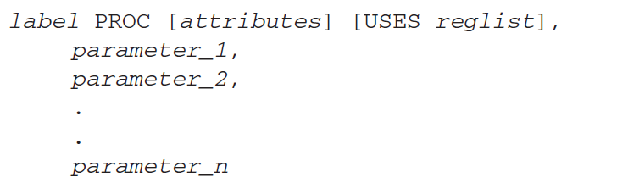

**ADDR Directive**



Using INVOKE and PROTO

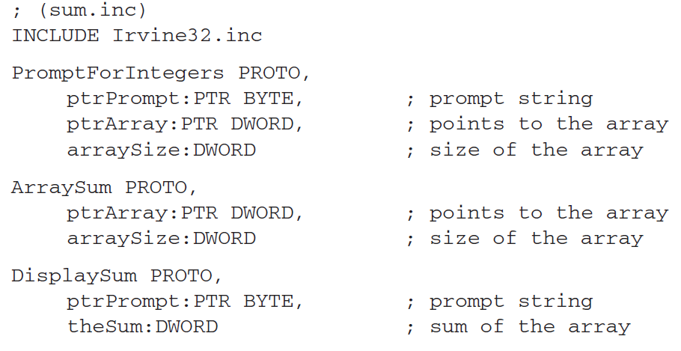

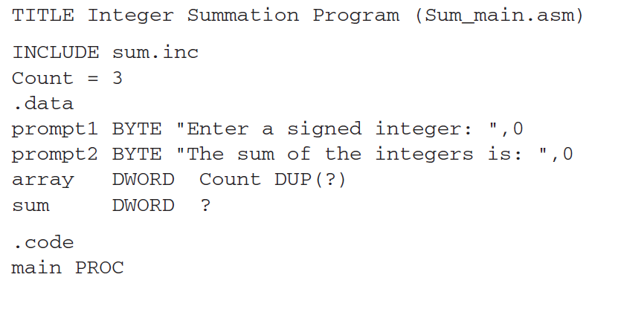

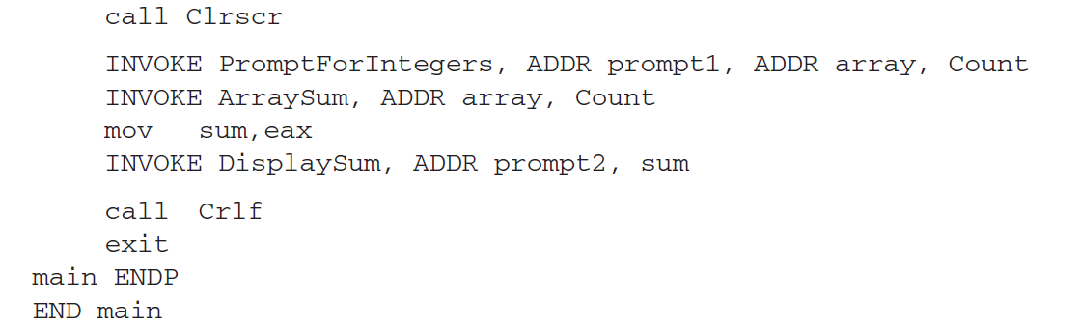

**Recursive Procedures**

Recursive procedures are those that call themselves to perform some task.

**EXAMPLE:**

.code

mov ecx, 5

mov eax, 0

call CalcSum

L1:

call WriteDec

call crlf

exit

CalcSum PROC

cmp ecx, 0

jz L2

add eax, ecx

dec ecx

call CalcSum

L2:

ret

CalcSum ENDP

**ACTIVITIES:**

1. Write a program which contains a procedure named **ThreeProd** that displays the product of three numeric parameters passed through a stack.

2. Write a program which contains a procedure named **MinMaxArray** that displays the minimum & maximum values in an array. Pass a size-20 array by reference to this procedure.

3. Write a program which contains a procedure named **LocalSquare**.The procedure must declare a local variable. Initialize this variable by taking an input value from the user and then display its square. Use **ENTER*& LEAVE*** instructions to allocate and de-allocate the local variable.

4. Write a program to take 4 input numbers from the users. Then make two procedures **CheckPrime** and **LargestPrime**. The program should first check if a given number is a prime number or not. If all of the input numbers are prime numbers then the program should call the procedure LargestPrime.

CheckPrime: This procedure tests if a number is prime or not

LargestPrime: This procedure finds and displays the largest of the four prime numbers.